Sales Performance & Customer Trend Analysis
Data Analytics Project

Name: Harshal D. Kamdi
Role: Data Analytics Intern Candidate
Tools Used: Python | SQL | Power BI

1. Problem Statement
Businesses generate large volumes of sales data but often struggle to extract meaningful insights from it. Key challenges include understanding overall sales performance, identifying top-performing product categories, analysing customer purchasing behaviour, and evaluating regional sales trends.
Objective:
To analyse historical sales data and build an interactive dashboard that provides actionable insights to support business decision-making.

2. Dataset Description
The dataset used in this project represents retail sales transactions.
Dataset Details:
- Source: Retail / Superstore Sales Dataset
- Data Type: Structured tabular data
- Records include order, customer, product, and region details
Key Columns:
- Transaction ID
- Date
- Customer ID
- Gende
- Age,
- Product Category
- Quantity
- Price per Unit
- Sales

Data Cleaning Steps:
- Removed duplicate records
- Handled missing values
- Created a Sales column using total transaction amount

3. Tools Used
The following tools were used to perform analysis and visualization:
- Python
  - Pandas for data manipulation
  - Matplotlib for basic visualizations
- Power BI
  - Interactive dashboards
  - KPIs and visual reports

4. Key Analysis Performed
The analysis focused on answering real business questions:
- Total Sales and Total Orders
- Monthly Sales Trend
- Sales by Product Category
- Top Customers by Revenue

5. Dashboard Overview
An interactive Power BI dashboard was created to visualize insights.
Dashboard Components:
- KPI Cards: Total Sales, Total Orders, Total Customers
- Line Chart: Sales trend over time
- Bar Chart: Sales by product category
- Pie Chart / Treemap: Category-wise contribution
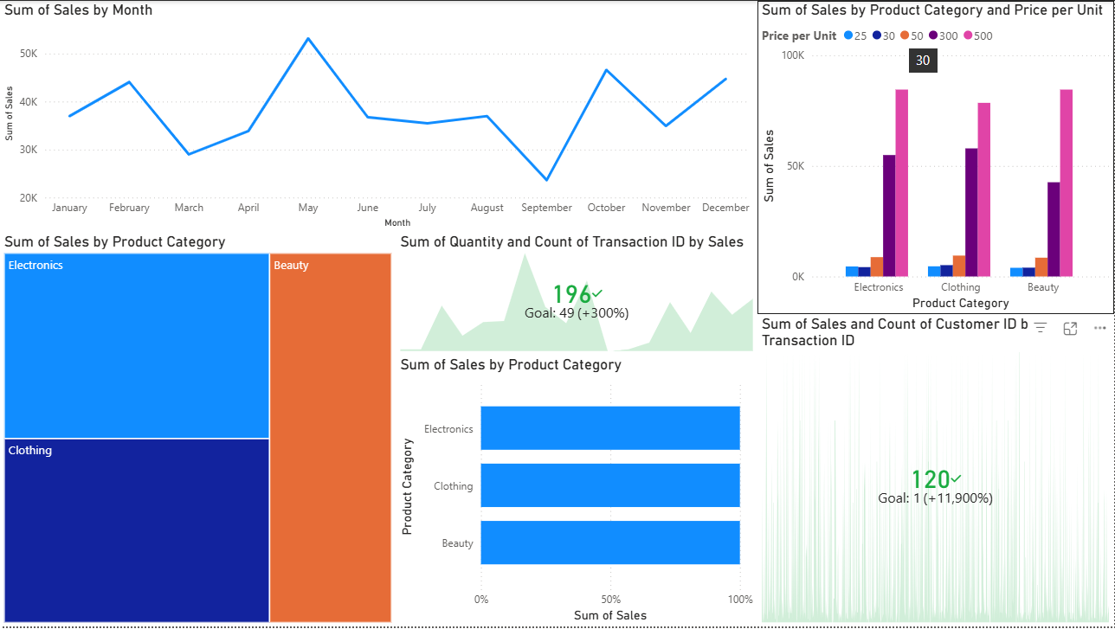
6. Business Insights
- A small number of product categories contribute a major share of total revenue
- Sales show noticeable seasonal trends
These insights can help businesses improve inventory planning and customer targeting

7. Conclusion
This project demonstrates an end-to-end data analytics workflow, starting from data cleaning and analysis to dashboard creation and insight generation.
Key Outcomes:
- Transformed raw sales data into meaningful business insights
- Built an interactive and user-friendly Power BI dashboard

